# ASSESSMENT OF RISK EXPOSURE IN OIL AND GAS DEPOTS OF NIGER DELTA, NIGERIA

**Grace Eyo Attih1, John Ugdebor2, Ejikeme Ugwoha3**

**Centre For Occupational Health, Safety and Environment (COHSE) Institute Of Petroleum Studies, Graduate School of Occupational Health and Safety**

**University Of Port Harcourt, Nigeria.**

# ABSTRACT

*The assessments of risks exposures of workers in oil and gas depots in Niger Delta were studied. Tank farms and oil depots store large volume of flammable petroleum products, which are hazardous to the workers and pose environmental threat due to poor facility maintenance. It was on this premise that this research examined health risk exposure associated with these hazards. The study adopted a cross-sectional design where data were collected from 182 tank/depot workers purposively using questionnaire. A total of 200 copies of a closed ended questionnaire were administered to all cadres of staff which comprised of senior staff, middle and junior staff. Data were coded and analysed at 95% confidence level. Respondents acknowledged that tank farms are plagued with all types of occupational and health hazards that are of great risks to workers, asset and the environment grand weighted mean of 3.67. The results showed that there is a significant relationship between hazards and health risk exposure vary among workers in different tank farms and depots. The study recommends frequent inspection of machines; turn around maintenance of facilities and promotion of healthy work environment within the tank farms and depots.*

Keywords: Risk Exposure, Environmental, Depots

# INTRODUCTION

Oil depots, such as oil terminals or gas stations, are designed to hold enormous quantities of combustible petroleum products. Spills, leaks, and/or drain during cleaning, big fires or explosions, and accidents occur frequently during storage tank maintenance, such as welding, loading, and unloading operations. With Nigeria's rapid economic expansion and high petroleum consumption, competent oil depot management has become progressively pertinent in preventing or at least minimizing such mishaps. Nigeria's high prevalence of industrial accidents has resulted in numerous fatalities and property losses. The frequent and high exposure of workers to dangerous working conditions has resulted to numerous work-related injuries and diseases in the sector. As more people continuously work in tank farms and depots with old instruments and equipment, defective machines, and low levels of safety measures, workers affected seem to be rising. Workplace accidents and mishaps are common at depots, owing to lack of awareness potential hazards and non-compliance with safety procedures, norms and regulations of companies.

Occupational hazards and dangers may lead to severe injuries, permanent incapacitation or morbidity and even death. It may further result to lower production, heavy equipment damage, material loss, and environmental deterioration. On this basis, it is vital to scrutinize the occupational dangers, risks, and facility integrity of oil and gas tank farms and depots in the Niger- Delta region of Nigeria. For decades, Nigeria's economy has exclusively relied on crude, primarily sourced from the Niger-Delta region. Hence, employee’s health in oil industry is critical to their firms' productivity and nation’s economy. Despite the fact that techniques to regulate, mitigate, or possibly prevent occupational hazards and health risks have been implemented over time, these hazards continue to occur on a regular basis, causing human suffering and financial hardship.

Some of the risks found in oil and gas plants have the potential to damage employees. The majority of accidents/hazards at oil and gas facilities result in employees' temporary or permanent inability to perform their duties, possibly caused by poor occupational health practices among oil and gas

facilities or their personnel. Employees are exposed to health risks and dangers, prompting this study.

## Hypothesis for Research

Ho: There is no significant difference in the risk exposure to oil and gas workers in the facilities.

Human Factor Theory

Ferrel (1997) developed the theory based on human factors; he believed that accidents result mainly from human error, inappropriate activities, overload and inappropriate response (Seyyed, 2012; Goetsch, 2010). Human factors theory attributes accident causation to chain of human errors as shown in Figure 2.2.

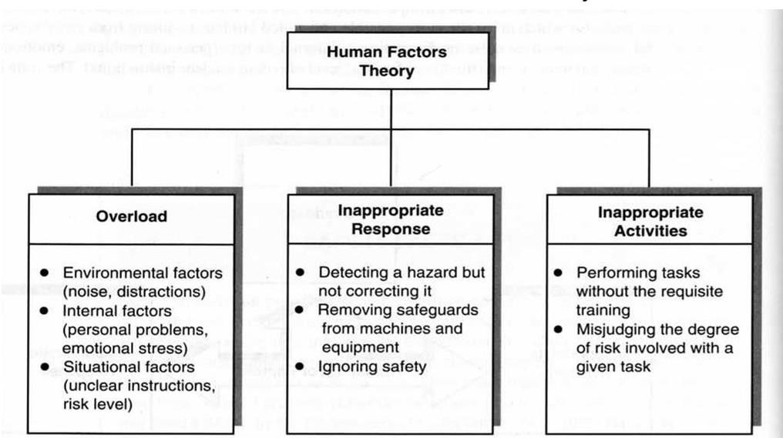

**Figure 2.2:** Human factors theory attributes accident causation to chain of human errors (Seyyed, 2012)

Accident/ Incident Theory

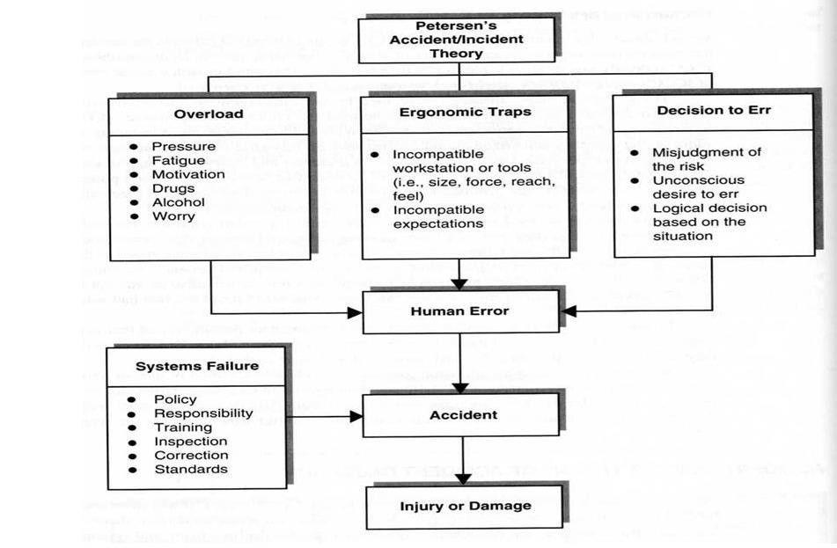Figure 2.3 highlight accident and incident theory developed by Dan Peterson who postulated that some reasons responsible for systems failure are; failure of management to establish comprehensive safety policy, undefined responsibility/authority to safety and safety procedures, like measurement, investigations, inspection and correction, insufficient attention and failure to give employees appropriate orientation and training (Torghabeh, 2012).

**Figure 2.3:** Accident/ incident theory

**Source:**Torghabeh, 2012

Epidemiology theory study causal relationships between diseases and environmental factors. ‘Epidemiological theory holds that the models used for studying and determining these relationships can also be used to study casual relationships between environmental factors and accidents. Jane Andrews was the newest member of the loading unit for Construction Products, Inc. She had 2 days of training on proper lifting techniques before beginning the work and mandatory use of back-support belts. Her supervisor and colleagues pressured her to disregard the proper lifting methods she learned in training. She followed her supervisor and after 2 months had to undergo major surgery to repair two ruptured disks. The theory has two Components which includes Predisposition Characteristics, Situational Characteristics’ (Saad, 2017).

## Occupational Risk

Risk is the chances or probability that harm will happen under certain conditions of exposure to a substance or object (Patrick *et al.,* 1986). Risk simply means the likelihood of hazard to cause harm (or injury) to a person (Tang, 2016). It is the measure of both the hazard and probability of harm to occurrence. Reducing risk is based on minimizing exposure to hazards. Mathematically, risk is a function of; hazard and exposure; exposure is a Function of dose and exposure time; therefore, Risk is a function of hazard, dose and exposure time. Thus, hazardous substance which pose only a small hazard but to which there is frequent or excessive exposure may pose as much risk as chemicals having degree of hazard but have only limited exposure. Risk can be minimized by reducing exposure time. The European Community defines risk as a function of; severity and probability of harm to occur (Okafor & Alamina, 2018), which depends on exposure duration and frequency, occurrence of hazardous events alongside the possibility of preventing, avoiding or limiting the harm.

The following elements of Industrial Hazard and Risk are as defined below:

1. **Harm:** This refers to any physical damage to a body caused by accident or violence. It may be physical injury/damage to health caused directly or indirectly as a consequence of hazards (ISO 14121:1999).
2. **Hazardous Condition:** Circumstance in a work-environment where by a worker is exposed to a hard event (ISO 14121:1999).
3. **Hazardous Event**: This refers to a hazardous condition that may cause harm to personnel (ISO 14121:1999).
4. **Accident:** Workplace accident is anything that happens suddenly or by chance that may cause harm or injury to workers. It is an unfortunate occurrence or mishap that causes damage or injury to workers.
5. **Tolerable Risk:** The acceptable level of risk, which has little or negligible effects on the workers.

## Risk Assessment

Risk assessment is a systematic process of identifying risk in a hazard. It is the process of identifying hazards and evaluating the associated-risk with the hazards considering control measures (British Standards 8800, 2004). According to Lind (2017), risk assessment has a procedure**.** “Industrial risk assessment is the procedure employed in the industry to identify the probability or Likelihood that a worker may be harmed or injured when exposed to workplace hazards,” (California State University Maritime Academy, 2017). In 1983, the United States National Research Council (NCR) established a quantitative and systematic approach to Risk Assessment in work environment (National Research Council, 1983). The NRC considered risk assessment process as an activity carried-out by the application of scientific objective principles; the council a1so viewed risk management as a decision making process that encompasses all sphere of life. Occupational risks are assessed using various established methods and technique. These methods are employed to assess occupational risks such as ergonomics or injury risks in

specific tasks. Risk assessment methods, such as such as ergonomics or injury risks (HAZOP) and Fault Mode and Effects Analysis (FMEA) are used to identify system risks (Lind, 2009).

As opined by Koornneef & Hale (1997) Standards for risk assessment are SFS-EN ISO 12100-1 (2003) and ISO 14121 (1999) for machine safety standards, SFS-IEC 60300-3-9 (2000) for quality management standard and British Standards 880 (2004) for safety management standard. These standards describe risk assessment process based on identification of hazards, risk analysis, and the management techniques as presented in Figure 2.23 (Lind, 2009). The risk management techniques or control measures emp1oyed should one that the risk is reduced to an acceptable level according to ISO I 2100-1:2003 standard (Lind, 2009). The risk management part is aimed at removing or reducing the risk. Risk can be reduced by either the likelihood or consequences (Kumamoto & Henley, 1996). This could be of setting barriers between personnel and risks .as suggested by Hollnagel (2004) and in Management Oversight and Risk Tree (MORT) risk analysis method (Koornneef & Hale.1997).

## Hazard Identification and Risk Assessment

Hazard identification and risk assessment (HIRA) is ‘the process used to acknowledge the existence of a hazard, and to define and describe its characteristics, probability of frequency of occurrence and severity as well as evaluating its adverse effects such as injuries and losses (BS 8800:2004; Magibalan, *et al.,* 2017). For the petroleum industry to successfully achieve a high level of productivity there is need to maintain the highest level of safety standards. The identification of hazards is an essential aspect of safety hazard process in an Environment. Hazard identified in the industry and the associated risks assessed, managed to tolerable level on a continuous basis (California State University Maritime Academy, 2017)’. ‘The risk assessment should be performed using risk assessment guidelines and such as the BS 8800:2004 and ISO 14121:1999 standards. Moderately foreseeable hazardous events and hazardous situations in workplace are systematically identified with the hazard identification and risk assessment process (HIRA). An example of a Health Examination Risk Assessment is Job Hazard Analysis (JHA). Hazard Identification (HAZID) is a process of determining the existence of hazards and defining their characteristics (BS 8800:2004), is the first (1st) step in risk-assessment’ (Magibalan *et al.,* 2017).

A potential of hazard source of harm is referred to as hazard (ISO 14121: 1999; Lind, 2009). Hazard identification is based on its source of origin (such as noise hazard) and the nature of its potential consequences (such as hearing impairment). Some hazards such as ergonomics hazards subsist permanently in a system or in a workplace environment due to the inherent nature of the system or certain features in the work environment. However, hazards can also occur circumstantially by chance as a result of certain conditions that may exist in the system or workplace (1SO 14121:1999; Lind, 2009).

The prevention of accident in an industrial work environment is based on risk analysis, which involves hazards identification. In the risk analysis process, the likelihood of occurrence of each hazard and its consequences are a1culated (Lind, 2009). According to British Standard 8800 (2004) risk is a product of the estimated likelihood of occurrence and the estimated severity of Consequences and (ISO 14121:1999; McCormick, 1981). Risk can be expressed in quantitative and qualitative terms (Kirchsteiger, 1999; Lind, 2009).

Quantitative risk assessment is presented in numerical risk values, while qualitative risk data are transformed into quantitative by assigning numerical risk values. The values are used to determine the severity of a risk and the appropriate corrective measures to be employed in order to reduce of minimize the risk (Lind, 2009). The British Standard 8800:2004 classified risk into very low, low high and very high risk. Very low risks are acceptable, whereas low, medium and high risks are to be reduced. Very high risks are considered as unacceptable (Lind, 2009). British standard 8800 numbered and rated risk as shown in Table 2.4 (Lind, 2009).

# METHODOLOGY

## Research Design

This study utilized a combination of field measurements and analytical cross-sectional research design.

## Study Area

The Niger Delta region is situated in the Gulf of Guinea between longitude 50E to 80E and latitudes 40N to 60N, as shown in Figure 3.1 (Opafunso, 2007). ERML (1997) defines the original Niger Delta region (about 29,900 square kilometres) as comprising the area covered by the natural delta of the River Niger and the areas to the east and west, which also produce oil.

## Population for the Study

The population in this study revolves around oil and gas facilities in the Niger Delta Region and includes all the individuals whose daily work activities exposes them to hazards and risks. It comprises of a group of facility workers of depots and tank farms in the Niger Delta, Nigeria, male and female between the age range of twenty-one (21) years to sixty (60) years in the oil and gas facilities (Public and Private Depots) whose duties and day to day business are such that they are exposed to hazards and risk in their work place or environment. This individual comprises staff and contract staff gainfully employed loaders, safety officers, health personnel, production staff, maintenance staff, lab scientist, site surveyors, all managers and supervisor of all cadres. The sampling size was determined as a subgroup from the study population.

Nigeria has a total of 124 depots across the country with a total of 38 tank storage in the Niger Delta. Breakdown is as follows; NNPC/PPMC tank farms Warri, Calabar, Port Harcourt and Aba. Independent Marketers storage farms Port Harcourt 12, Calabar11, Warri 4 and 1 in Akwa Ibom, Major Marketer’s storage farms, Port Harcourt 4 and Warri 1, giving a total of tank farm in Niger Delta. Most of the storage farms are not functional due to; the refineries are not producing products, pipeline vandalization and distance from the coast. However, in this study, six tank location companies were used, 3 public and 3 private Depots/tank farms. For confidential reasons as agreed with these companies, their names are not mentioned.

The study’s inclusion criteria were staff who have spent one year and above in the facilities and are active in their respective duties and with no adverse health challenges. While those who have history of psychotic (someone in a mental state of health that can exhibit abnormal behaviour) disorders based on personal declaration and from information obtained from their companies were excluded from the study.

## Determination of Sample Size

The study adopted a non-probability purposive-sampling technique. Representative samples were collected via sound judgment from the study population (Black, 2010). Oil facility workers that have been duly employed as staff/locum that can provide dependable information were purposely selected for the study. The determined sample size was obtained by utilizing Taro Yamane’s formula (1967) as shown in equation (3.1). It was determined on the estimated number of all the staff in the six tank farms which were given as N= 400

## Methods of Data Collection/Instrumentation

The primary data collection here means obtaining information by administering copies of questionnaire to respondents in selected depots oil and gas facilities in Niger delta region of Nigeria. Personal interviews were engaged in with some workers, which will enhance the worth of information that were derived from the questionnaire concerning occupational hazards and health risks. Before undertaking the data collection process, an official letter was addressed to respective managements in the various studied facility seeking the study-population's consent. Each management of the designated depots and tank farms were assured of treating the information from respondents/participant confidentially. Hence, the data collection procedure of the study

followed due process and study was done via; walk through survey, structured questionnaire, and review of documents, reports, secondary data, observations and an inspection checklist.

Structured Questionnaires

A questionnaire refers to a research instrument that consists of sets of questions for obtaining responses from respondents in a standardized way (Bhattacherjee, 2012). It is a technique used in collecting data from sampled population in which each individual responds to the same set of questions in a present order (Saunders *et al.,* 2012). The questionnaire was prepared in simple English language, so respondents can read and understand all the questions therein.

## Methods of Data Analysis

Preceding the data analysis, the returned copies of questionnaire were properly cross-checked for completeness and the incomplete copies alongside those with incorrect responses were discarded. Here, quantitative and qualitative techniques were adopted to analyse questionnaire and interview data respectively. The analysis was centred on the provided information obtained through questionnaire, checklist auditing and documentation. The qualitative data gathered from different sources were assembled, summarized and categorized to suit the analysis method. Collected data from copies of questionnaire were processed, coded and analysed utilizing XLSTAT 20l8 premium version software, developed by Addinsoft (2018). The percentage, mean and standard-deviation of respondents were determined. Contextual information of respondents was captured and presented in percentage. Qualitative data obtained from checklist auditing, notes and documents were systematically transcribed, coded and classified into broad descriptive categories before analysis.

Five-point Likert-Scale was used in analysing and evaluating sections B – E of the questionnaire. The individuals that constitute the sampled population were asked to respond to each question from their own degree of agreement or disagreement. They were directed to choose one of five responses of strongly agree, agree, disagree, or strongly disagree and undecided. To analyse the gathered data, each statement or item was coded and assigned weights as five (5) points were assigned to Strongly Agree (SA), four (4) points to Agree (AG), three (3) points to Undecided, two

(2) point to Disagree (D) and one (1) Strongly Disagreed. The responses to the itemized statement were combined or summed to obtain a total pact score. Responses on each questionnaire were considered high and agreed when the value mean is 3.00 and above and will be disagreed when it’s less than 3.00. It was calculated from the average weight of the response options,

That is, 𝑆𝐴+𝐴+𝑈+𝐷+𝑆𝐷

𝑛

(3.2)

5+4+3+2+1 = 3

5

It worth of note that the scale interval was equally distributed and for a statement to be considered

significant the weighted mean is equal to (or) greater than the criterion which was 3.0.

ANOVA stands for analysis of variance. It’s a statistical test developed by Ronald fisher in 1918 which has been used to identify differences in any statistical analysis between means of three or more independent groups. Pearson Product Moment Correlation (PPMC) coefficient is also called product moment correlation coefficient, the bivariate correlation is a measure of linear correlation between two sets of data. It shows the relationship between two (2) sets of data. The study considers assessment of occupational hazards, risks and facility integrity of Tank farms and depots in oil facilities in Niger Delta. As such the above PPMC is an appropriate correlation analysis for testing the relationship between occupational hazards exposure and the effect on workers. Health risk exposures affecting the workers correlate significantly with the level of workers awareness and workers safety behaviour.

## Results

Health Risk Exposures Associated to Workers in Oil and Gas Facilities

|  |  |  |  |  |  |  |  |
| --- | --- | --- | --- | --- | --- | --- | --- |
| **Referents** |  | **Companies Weighted Mean** | | | |  | **Grand Mean** |
| **A** | **B** | **C** | **D** | **E** | **F** |
| 1 | 1.60 | 2.33 | 4.08 | 4.61 | 4.54 | 4.36 | 3.51 |
| 2 | 3.70 | 4.00 | 4.31 | 4.67 | 4.69 | 4.21 | 4.24 |
| 3 | 2.05 | 1.42 | 2.77 | 3.89 | 4.08 | 3.38 | 2.93 |
| 4 | 2.15 | 1.92 | 4.38 | 4.22 | 4.15 | 4.14 | 3.46 |
| 5 | 2.63 | 3.17 | 4.62 | 4.61 | 4.31 | 3.43 | 3.76 |
| 6 | 3.80 | 4.50 | 3.15 | 4.33 | 3.38 | 3.71 | 3.83 |
| 7 | 4.50 | 4.67 | 4.15 | 4.39 | 4.15 | 4.36 | 4.38 |
| 8 | 4.55 | 4.83 | 4.62 | 4.28 | 4.31 | 4.36 | 4.48 |
| 9 | 4.20 | 4.50 | 4.38 | 4.11 | 4.38 | 4.50 | 4.32 |
| 10 | 1.60 | 1.25 | 1.62 | 2.28 | 1.08 | 1.50 | 1.60 |
| **Total** | **3.08** | **3.26** | **3.81** | **4.14** | **3.91** | **3.80** | **3.65** |

## Hypothesis Testing

**Ho:** There is no significant difference in the risk exposure to oil and gas workers in the facilities

Table above shows the range of risk exposure experienced by oil and gas personnel in facilities from various companies in the area. At the 0.05 level of significance, the table displays an F-score of 48.068, which is higher than the crucial value of 2.21. With a significance level of 0.000, there is no way this divergence could have occurred by coincidence. As a result, the null hypothesis of no substantial difference in risk exposure for oil and gas workers in the facilities is rejected, whereas the alternative hypothesis is supported. This means that the risk of oil and gas employees at facilities varies depending on the study area.

Table above illustrates the post-hoc test (Duncan statistics) for the variation in risk exposure to oil and gas workers in the facilities from selected companies in the area. It is evident from the table that respondents in companies A, B, C, E, and F recorded lower values, while company D recorded higher values, which indicates higher perceptions in the risk exposure to oil and gas workers in this company. Furthermore, this result indicates that respondents in companies A and B are similar in their perception level; companies C, E and F also share similar perceptions; and the perception of respondents in company E is also similar to those of company D concerning the risk exposure to oil and gas workers in the facilities.

Health Risk Exposures Associated to Workers in Oil and Gas Facilities

|  |  |  |  |  |  |
| --- | --- | --- | --- | --- | --- |
| **ANOVA** | | | | | |
| **Risk Exposure** |  |  |  |  |  |
|  | **Sum of Squares** | **df** | **Mean Square** | **F** | **Sig.** |
| Between Groups | 14.180 | 5 | 2.836 | 48.068 | .000 |
| Within Groups | 10.464 | 176 | 0.059 |  |  |

|  |  |  |
| --- | --- | --- |
| Total | 24.644 | 181 |

Post-hoc Test, Risk Exposure

|  |  |  |  |  |
| --- | --- | --- | --- | --- |
| **Duncan** |  |  |  |  |
| **Company** | **N** | **Subset for alpha = 0.05** | | |
|  |  | 1 | 2 | 3 |
| A | 34 | 3.0772 |  |  |
| B | 30 | 3.2583 |  |  |
| F | 28 |  | 3.7937 |  |
| C | 26 |  | 3.8077 |  |
| E | 28 |  | 3.9077 | 3.9077 |
| D | 36 |  |  | 4.1389 |
| Sig. |  | 0.171 | 0.418 | 0.082 |
| Means for groups in homogeneous subsets are displayed. | | | | |
| a. Uses Harmonic Mean Sample Size = 14.487. | | | | |
| b. The group sizes are unequal. The harmonic mean of the group sizes is used. Type I error levels are not  guaranteed. | | | | |

## Discussion of Findings

Health Risk Exposures in the Tank Farms/Depots

Staff members are exposed to physical risk such as noise in the workplace, workers are exposed to chemicals that might harm their health, workers are occasionally subjected to psychological hazards such as excessive work load, and workers are exposed to biological hazards such as tuberculosis. In conclusion, most respondents believed that workers inhale and consume harmful substances that spill on their skin regularly. This was underpinned by the weighted mean, which showed that each company’s scores were higher than the criterion mean of 3 and had a grand mean of 4.24. Also, most respondents in firms A, B, and C disagreed that their workplace lacks sufficient environmental hygiene, whereas the majority of respondents in other companies agreed. The weighted mean result confirmed this, as the scores for firms A, B, and C were all below the criterion mean of 3, whereas the weighted mean of the other companies was above 3. In general, respondents disagreed with the assertion that my workplace lacks sufficient environmental hygiene, as seen by the grand mean of 2.93.

One of the greatest hazards to workers in the tank farm and depot is inhalation of fumes and splashes of product while loading vehicles or taking product samples for analysis. From respondents’ views, workers inhale and absorb harmful chemicals that spill onto their skin on occasional basis. Most respondents (90.0%) agreed that workers inhale and absorb hazardous substances that spill on their skin on occasion. A weighted mean of 3.70 indicates that the assertion is generally accepted. This remark backs up a prior study that concluded that "chemical emissions occur when a chemical is released from a wide region, such as an industrial site, or from a container, such as a drum or bottle, into the environment." It is thus possible to be exposed to it in the environment via breathing, eating, or drinking things that contain the chemical, alongside via skin contact."

The findings show how many new employees took part in pre-employment training. In firm A, most respondents (73.7%) agreed that they received pre-employment training when they first started working, and 26.3 percent disagreeing. A weighted average of 4.00 indicates that the statement is generally agreed upon. OHS in Nigeria's oil & gas industry was investigated by Asikhia and Emenike (2013). Workers are exposed to divers’ dangers at work, according to the findings. Shaikh and Weiguo (2018) conducted an empirical investigation on OHS facilities and worker performance in the manufacturing business. Workers' performance is positively correlated with

OHS facilities, according to the findings. Evidence shows that the workers did not receive OHSFs on timely manner. Both assumptions are supported by the outcome of this study, principally because workers are typically exposed to a variety of dangers in the workplace. This infers that if comprehensive health assessments are performed on all employees, appropriate health facilities are provided, and existing legislation is enforced and strengthened to limit these hazards, workers in oil and gas firms will face less occupational health risk. This should take private and public oil & gas infrastructure into account.

# CONCLUSION

In conclusion, workers at tank farms and depots face occupational risks, from the report. Due to frequent and continuous use, alongside exposure to the elements, machines and other service facilities deteriorate. The deterioration must be addressed using variety of maintenance intervention approaches at predetermined intervals to maintain the required use of facilities and service life. As a result, when a thorough health risk-assessment is conducted and workplace OHS regulations are rigorously followed in Tank farms and/or depots, the risk of illness or disorder among workers would be prevented/greatly minimized. Additionally, when a safety regulatory authority enforces compliance with OHS measures, such as corporations hosting regular training on risk and hazard awareness, it decreases workplace dangers and risk.

# RECOMMENDATIONS

1. Oil & Gas companies should conduct risk management covering in three aspects: increasing the hazard-awareness level, enhancing system ventilation, and improving personal health management measures.
2. Management of oil & gas companies should be fully committed to OHS of workers, alongside build an active OHS system.
3. It is of note that the studied tank farms and depots have not carried out turn around maintenance of the facilities, but inspections and minor prompt repairs resulting in in overwork and stress of most machines which may result in serious disaster to the facility and the environment. Therefore, facilities can be shut down at least one in two years for turnaround maintenance to ensure facility integrity, prevent industrial accident and promote maximum productivity.

# REFERENCES

Asikhia, M.O., & Emenike, G.C. (2013). Occupational health and safety in the oil and gas industry in Nigeria *JORIND 11*(2), 61-72.

Henderson, VL., Enterline, PE., Marsh, GM., Esmen, NA., Callahan, CM., & Paik, M, (2007). Some effects of cigarette smoking, arsenic, and SO2 on mortality among US copper smelter workers. *Journal of Occupational Medicine, 29,* 831–838.

Hassinger, E. & Watson, J.E (2021). Storage of Petroleum Products. DOI: 015.11pdf.

FARM*A*SYST. Farm/Ranch Self-Assessment System for Arizona.

Johnson, R.W. (2000). Risk management by risk magnitudes. *Unwin Company Integrated Risk Management*, 1–2.

Kalejaiye, P.O. (2013). Occupational Health and Safety: Issues; challenges and compensation in Nigeria. *Peak journal public Health and management*, *1*(2)*,* 16-23.

Nnadi U., David, Z. E., Smyth, D. & Mooney, J. (2017) Lack of Proper Safety Management Systems in Nigeria Oil and Gas Pipelines. School of engineering. University of the West Scotland Paisley campus. PAI 2BE, UK.

Ogbuigwe, A. (2018) Refining in Nigeria History, Challenges and prospects. NNPC archives.

Okoye, A.C., Odumegwu, C.O., & Omuku, P.E. (2012). Evaluation of the level of safety consciousness in Municipal Waste Management in Anambra State, Nigeria. *Journal of Environmental Management and Safety, 3*(1), 90-96.